Pass for level 12: EDXp0pS26wLKHZy1rDBPUZk0RKfLGIR3

Step 1: Entering to natas 11

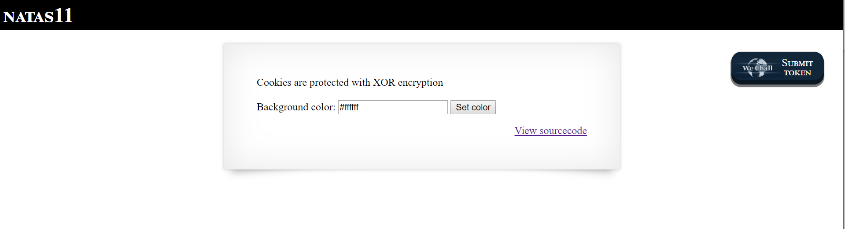

We can see buttons and option to change background colors.

Also we saw that there is some information in cookies that store with XOR encryption.

Then we learned that key = plaintext XOR ciphertext

After we look for XOR encryption we click inside view source code.

Step 2: Source code

<http://natas11.natas.labs.overthewire.org/index-source.html>

We saw some functions in php like:

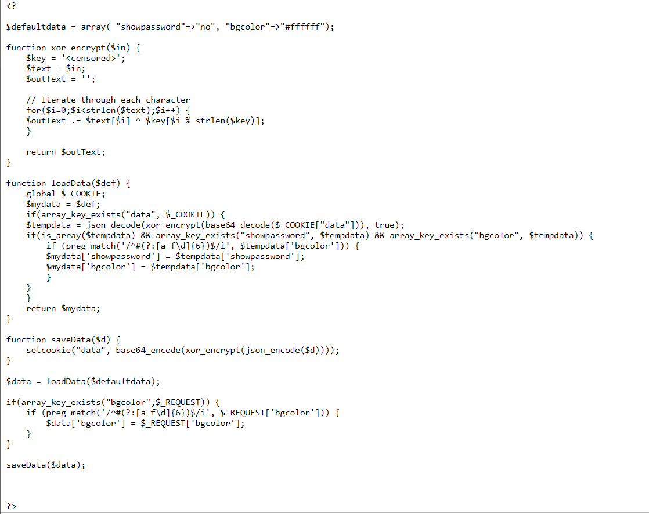

The key is censored then we need to extract some information.

Step 3:Finding the key.

I created PHP program which doing ciphertext XOR plaintext = key.

Called level11.php and we got that key is: **qw8J**



Step 4: Now we create once again the original plaintext and then XOR with the key

And the following output is:



Then I set the cookies in python style with the program level11.py

And get:

